**MICROSERVIC WITH SPRING CLOUD**

**Microservice****Architecture****……………………………………... 1**

**Service Discovery****……………………………………………… 2**

**API Gateway****………………………………………………….. 3**

**Cloud Config Server****…………………………………………… 4**

**Microservices** **…………………………………………………. 5**

**Distributed Tracing Tool** **………………………………………. 6**

##### Microservice Architecture

API Gateway

Customer

Service

Department

Service

Config Server

Service Registry

Git

##### 

##### 

##### 

##### Service Discovery

service-registry:

* This is application is service discovery or registry. It manages all microservices port detail, uri information and so on.

🡺 open <https://start.spring.io/>

🡺 Add Eureka Server (Spring cloud discovery) and generate the war file and import it to IDE

🡺 Create application.yml in resources 🡺 add bellow configuration

🡺 To register services to Eureka Server, Open <https://start.spring.io/> 🡺 add Eureka Discovery Client (Spring

cloud discovery) dependency not Eureka Server and copy the dependency 🡺 add it to all microservices such

as customer-services and department-services.

1, **<spring-cloud.version>**2021.0.4**</spring-cloud.version> inside <properties>**

**2, <dependency>**

**<groupId>**org.springframework.cloud**</groupId>**

**<artifactId>**spring-cloud-starter-netflix-eureka-server**</artifactId>**

**</dependency>**

3, **<dependencyManagement>**

**<dependencies>**

**<dependency>**

**<groupId>**org.springframework.cloud**</groupId>**

**<artifactId>**spring-cloud-dependencies**</artifactId>**

**<version>**${spring-cloud.version}**</version>**

**<type>**pom**</type>**

**<scope>**import**</scope>**

**</dependency>**

**</dependencies>**

**</dependencyManagement>**

**<build>**

**<plugins>**

**<plugin>**

**<groupId>**org.springframework.boot**</groupId>**

**<artifactId>**spring-boot-maven-plugin**</artifactId>**

**</plugin>**

**</plugins>**

**</build>**

🡺 We also supposed to add bellow configuration to each microservices and gateway server. But, we will add

this configuration into cloud config to avoid repetitive configuration.

🡺 We add bellow snippet of code into microservice main class who wants to contact other microservices

// Automatically do the load balancing whenever we use this template to communicate between

microservices

@Bean

@LoadBalanced

public RestTemplate restTemplate(){

return new RestTemplate();

}

🡺 Later we will open <http://localhost:8761/> and verify the services if added successfully.

##### API Gateway

**cloud-gateway:**

* This is API gateway it routs call to customer-service and department-service microservices by using only one URL endpoint. E.x <http://localhost:9191/customer/1> we only change name to make different call

🡺 open <https://start.spring.io/>

🡺 Add Eureka Discovery Client (Spring cloud discovery) dependency not Eureka Server

🡺 Add Gateway (Spring cloud routing) dependency

🡺 Add Actuator (Spring spring boot ops ) dependency

🡺 Generate jar file and open it with IDE and create application.yml and configure it bellows snippet

🡺 To point application to config-server application add bellow dependency and create bootstrap.yml

(external cloud configuration yml) in resources and add bellow configuration

<dependency>

<groupId> org.springframework.cloud </groupId>

<artifactId>spring-cloud-starter-config</artifactId>

</dependency>

##### Cloud Config Server

**config-server:**

* This application a centralized config server which help as to config all microservices, gateway, & config server in remoter repository GitHub.

🡺 open <https://start.spring.io/>

🡺 Add Eureka Discovery Client (Spring cloud discovery) dependency not Eureka Server

🡺 Add Config Server (Spring Cloud Config) dependency

🡺 Enable @EnableConfigServer @EnableEurekaClient

🡺 Create application.yml file and add below config to connect to git repository

**department-service:**

* This application a micro service rest Api. It adds department.

🡺 open <https://start.spring.io/>

🡺 Add Spring Web, Spring Data JP, H2 Database SQL(for demo purpose h2 used), and Lombok. Open

application with IDE.

🡺 Post method to add department (this uri is after gateway is connected to microservices)

<http://localhost:9191/department/>

{

"departmentName": "IT",

"depatmentAddress": "1212 A st, California",

"departmentCode": "IT-123"

}

🡺 Get method to get added department <http://localhost:9191/department/1>

##### Microservices

**customer-service:**

* This application is a micro service rest Api. It adds customer.

🡺 open <https://start.spring.io/>

🡺 Add Spring Web, Spring Data JP, H2 Database SQL(for demo purpose h2 used), and Lombok. Open

application with IDE.

🡺 Post method to add department (this uri is after gateway is connected to microservices)

<http://localhost:9191/customer/>

{

"firstName": "Peter",

"lastName": "Wang",

"email": "peter@gmail.com",

"departmentId": "2"

}

🡺 Get method to get added department <http://localhost:9191/customer/1>

##### Distributed Tracing Tool

**zipkin:**

* This is a distributed tracing system.

🡺 Add bellow dependency to all microservices so that Zipkin can trace the activity

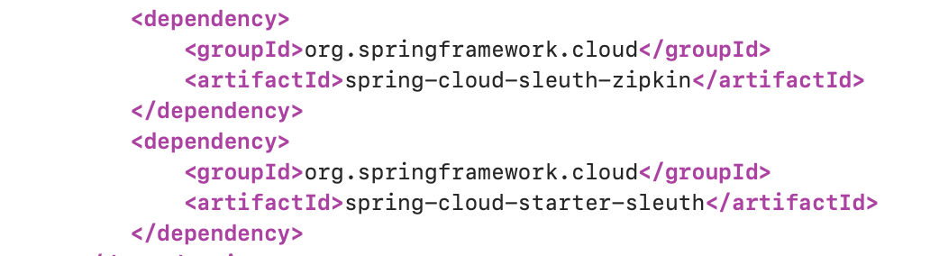

🡺 download Zipkins and run java -jar zipkin-server-2.23.18-exec.jar command

🡺 Open <http://127.0.0.1:9411/zipkin/> and check if services are register by sending queries